Stroke Classification Segmentation
System Architecture

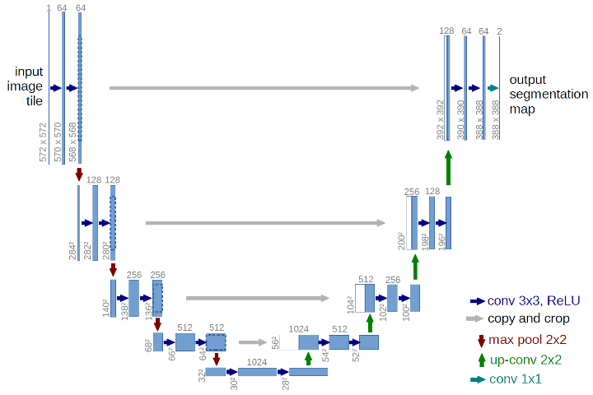
Overview
The proposed system aims to automatically perform brain stroke segmentation and classification from Computed Tomography (CT) scan images using a hybrid deep learning framework. The system integrates a U-Net-based convolutional neural network (CNN) for pixel-level stroke segmentation with a Transformer-based architecture for modeling inter-slice dependencies in three-dimensional (3D) CT volumes.
This modular architecture enables accurate spatial localization of stroke regions while effectively capturing volumetric contextual information, which is critical for reliable clinical diagnosis.
Input Data and Preprocessing
The input to the system consists of grayscale brain CT scan images. Since CT data is inherently three-dimensional, each scan is represented as a sequence of two-dimensional (2D) slices.
Prior to training and inference, the following preprocessing steps are applied:
- Conversion of images to grayscale format (if required)
- Normalization of pixel intensities to the range [0, 1]
- Resizing of images to a fixed spatial resolution
- Conversion of images and segmentation masks into tensor representations
These steps ensure consistency across the dataset and improve training stability.

U-Net Based Segmentation Module
A U-Net architecture is employed for slice-level stroke segmentation. The U-Net follows an encoder–decoder structure with skip connections, allowing the model to capture both low-level spatial details and high-level semantic features.
The encoder progressively extracts hierarchical features using convolutional and pooling operations, while the decoder reconstructs the segmentation mask using upsampling and feature concatenation. Dice Loss is used as the primary optimization objective to handle class imbalance commonly present in medical imaging datasets.
The output of this module is a binary segmentation mask that highlights stroke-affected regions in each CT slice.

U-Net Based Segmentation Module
A U-Net architecture is employed for slice-level stroke segmentation. The U-Net follows an encoder–decoder structure with skip connections, allowing the model to capture both low-level spatial details and high-level semantic features.
The encoder progressively extracts hierarchical features using convolutional and pooling operations, while the decoder reconstructs the segmentation mask using upsampling and feature concatenation. Dice Loss is used as the primary optimization objective to handle class imbalance commonly present in medical imaging datasets.
The output of this module is a binary segmentation mask that highlights stroke-affected regions in each CT slice.

Encoder Feature Extraction
After training the U-Net for segmentation, the decoder portion is removed, and only the encoder network is retained. This pretrained encoder serves as a robust feature extractor, transforming each CT slice into a high-dimensional latent representation.
These latent features capture clinically relevant information related to stroke appearance, such as intensity variations, texture patterns, and spatial structures.

Slice Sequence Formation
To incorporate volumetric context, feature vectors extracted from individual CT slices are stacked in their original anatomical order, forming a sequential representation of the entire CT volume. This sequence-based formulation enables the system to model spatial continuity and relationships between adjacent slices.

Transformer-Based Inter-Slice Modeling
A Transformer encoder is utilized to learn inter-slice dependencies within the CT volume. The self-attention mechanism enables the model to dynamically assign importance to different slices and capture long-range contextual relationships.
Positional encoding is applied to preserve the sequential ordering of slices. Multiple Transformer encoder layers are stacked to enhance representational capacity. This design effectively substitutes computationally expensive 3D convolutions while maintaining global contextual awareness.

Classification Module
The output embeddings from the Transformer encoder are aggregated using global pooling operations. The pooled representation is passed through fully connected layers to perform patient-level stroke classification.
The system predicts one of the following classes:
- Normal
- Ischemic Stroke
- Hemorrhagic Stroke
Cross-entropy loss is employed for classification training.

Model Training Strategy
The training process is divided into three distinct phases:
- Segmentation Training: The U-Net model is trained independently using slice-level segmentation masks.
- Classification Training: The pretrained encoder is frozen, and the Transformer and classification layers are trained using volume-level labels.
This staged training strategy ensures stable convergence and effective utilization of available annotations.

Inference
During inference, the trained model processes unseen CT scans by applying identical preprocessing steps. The system generates segmentation masks for individual slices and a final diagnostic classification for the entire CT volume. Model checkpoints are periodically saved during training and the most recent checkpoint is utilized for inference.

Initial Training Result
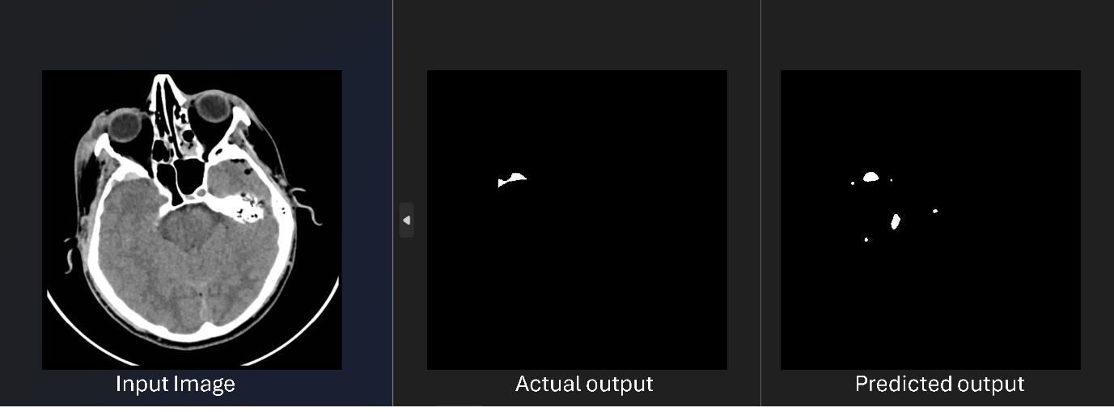

Training Loss Progress:
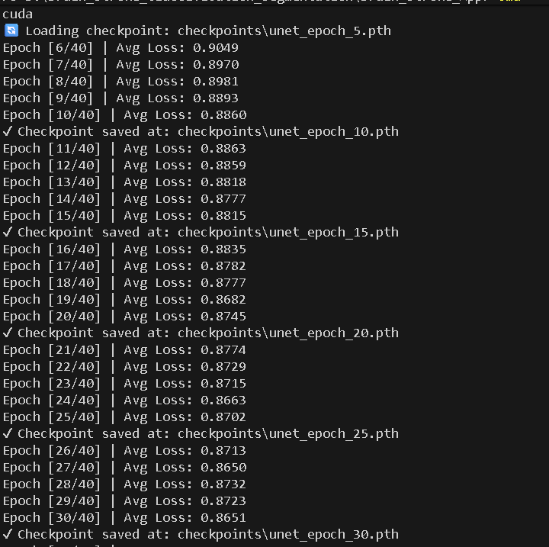

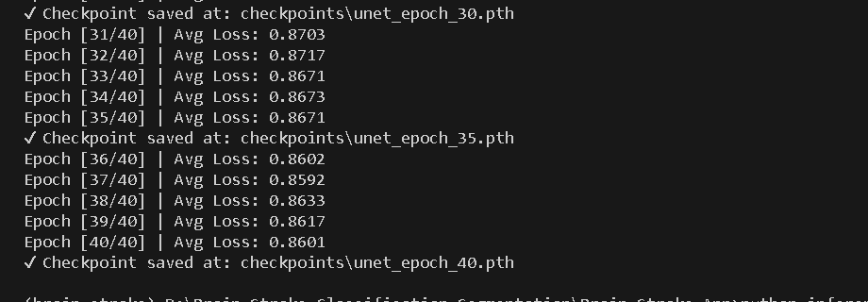
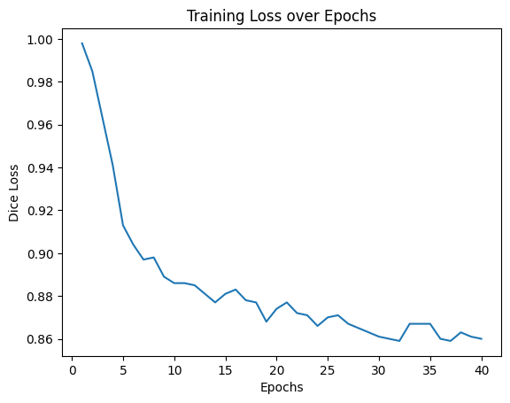

Note : Need to do further training to optimize the model.

